42.49: a) Each unit cell has one atom at its center and 8 atoms at its corners that are each shared by 8 other unit cells. So there are 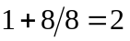atoms per unit cell.
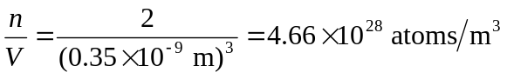
b) 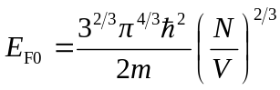

In this equation 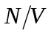 is the number of free electrons per 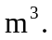 But the problem says to assume one free electron per atom, so this is the same as 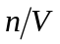 calculated in part (a).
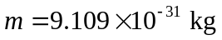(the electron mass), so 